BUILD A HONEYPOT SYSTEM

COWRIE HONEYPOT
This is a type of tool used in cybersecurity to detect and analyze malicious activity, typically targeting network systems.
Prerequisites for running cowrie:
- Linus based system
- Python 3.8
- Git
- Virtualenv

Steps in running cowrie includes:
- Sudo apt update
- Sudo apt upgrade -y (to install the recent necessary python file needed and upgrade the obsolete ones no longer in use
- Clone the cowrie repository using git: “git clone https://github.com//cowrie/cowrie.git” this command will clone your cowrie repository to your virtual machine.
- Cd cowrie ( to change directory to cowrie directory)
- Sudo apt install docker.io ( this is to install docker needed for running cowrie honeypot)
- Sudo systemctl status docker ( to check if docker is running)
- Sudo docker run -p 2222:2222 cowrie/cowrie:latest (this is start the cowrie honeypot operation, the reason we used 2222 as the port is to create a fake ssh port that looks exactly like the real ssh port 22, to attract attacker to attacker)
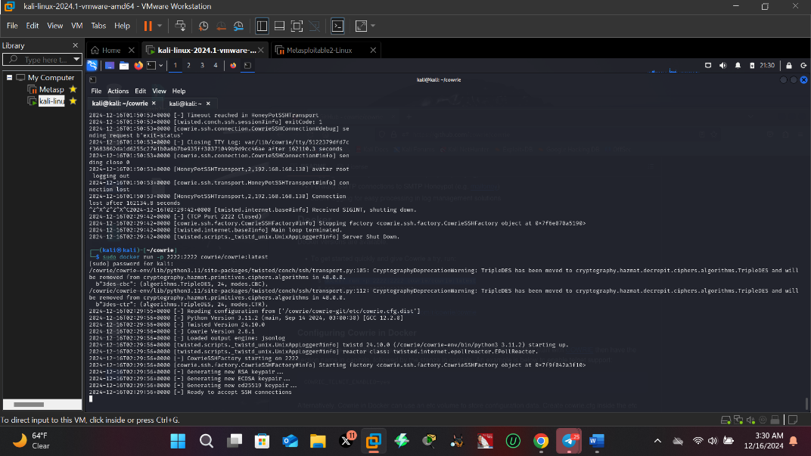

The pictures above is showing ready to accept ssh connection meaning the honeypot is set to record all network traffic going on within your virtual system. It monitor all commands your are using especially from attacker especially their attempt to login into your ssh port.
- nmap -p 2222 -sV 192.168.168.130 ( this is to check if the fake ssh port 2222 is open and host is up)

==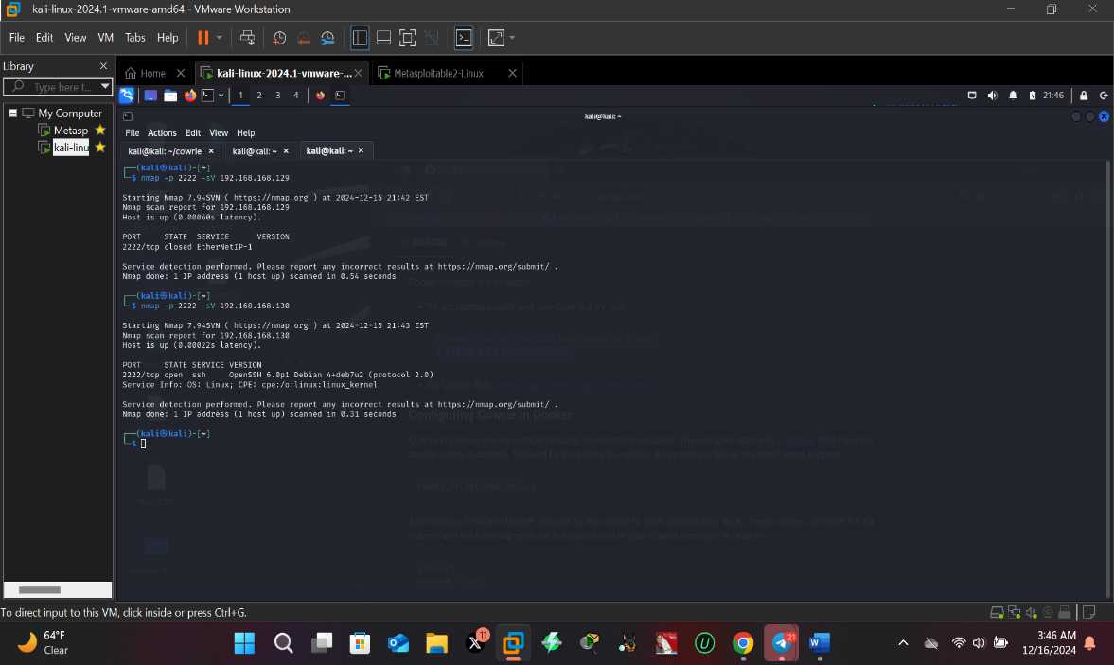

- open another terminal to test if the running cowrie honeypot can monitor any traffic or login attempt into the ssh port
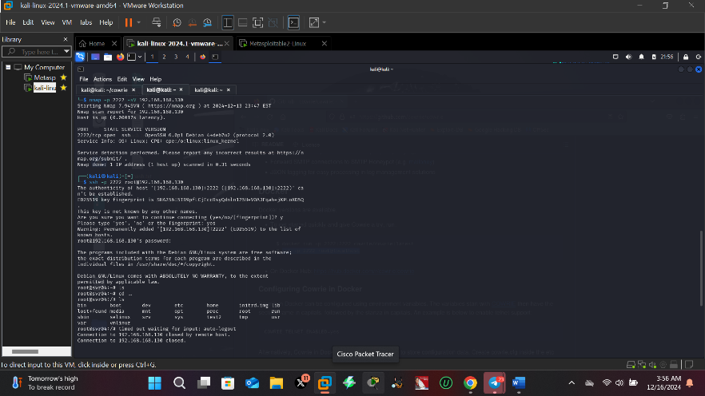

- the pics below is showing the various command I did inside ssh port recording all traffic
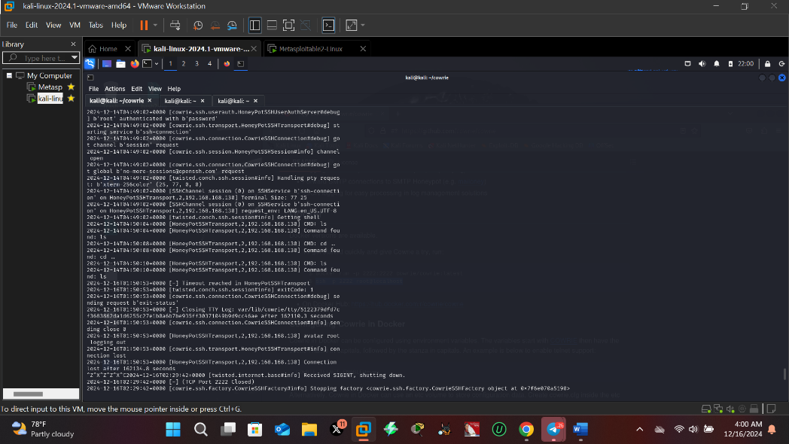
The pics above

